**HOSPITAL DATABASE MANAGEMENT SYSTEM**

**DATABASE SCHEMA**

**DATABASE:** HOSPITAL

**TABLES: 🡪** USER – (Admin, Patient, Doctor)-> ID(PK), username, password

(Patient, Doctor) -> name, next_appointment

**🡪** APPOINTMENT – Doctor ID (FK), day, slot

**TABLES**

**USER**

* USERNAME
* PASSWORD
* USER TYPE

**DOCTOR**

* D_ID
* NAME
* SPECIALIZATION

**PATIENT**

* P_ID
* NAME
* NEXT_APPOINTMENT

**AVAILABILITY**

* D_ID
* DAY
* SLOT
* STATUS
* APPOINTMENT_ID

**APPOINTMENT**

* APPOINTMENT_ID
* P_ID
* D_ID

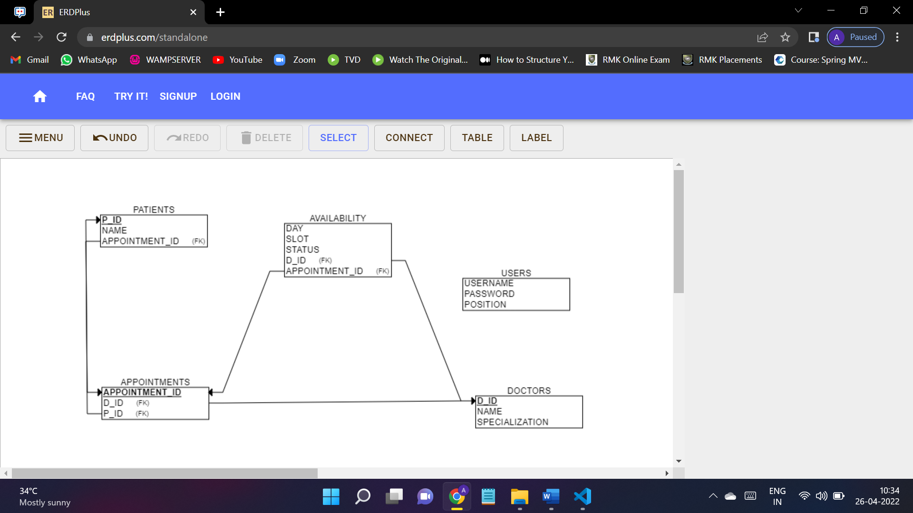

**USE CASES:**

**ADMIN:**

* register – register as a user
* Login – login to the system as an admin
* Logout – logout from the system
* changePassword – change password for the login id
* addUser– add new patients/doctors to the database
* removeUser – remove a particular patient/ doctor
* updateUser – update details of doctors or patients
* viewUser– view particular patient’s/ doctor’s details
* viewAllPatients – view all the patients and their details
* viewAllDoctors – view all the doctors and their details

**PATIENT:**

* Login – login to the system
* Logout – logout from the system
* changePassword – change the password for the login id
* scheduleAppointment – schedule an appointment based on the available slots
* rescheduleAppointment – reschedule an appointment to another available slot.
* cancelAppointment – cancel an appointment from the scheduled appointments.

**DOCTOR:**

* Login – login to the system
* Logout – logout from the system
* changePassword – change the password for the login id
* rescheduleAppointment – reschedule an appointment based on the available slots
* cancelAppointment – cancel an appointment from the scheduled appointments.
* viewAppointments – view all the appointments.
* updateAvailability – create slots for patients to choose from.

Other use cases:

checkAvailability

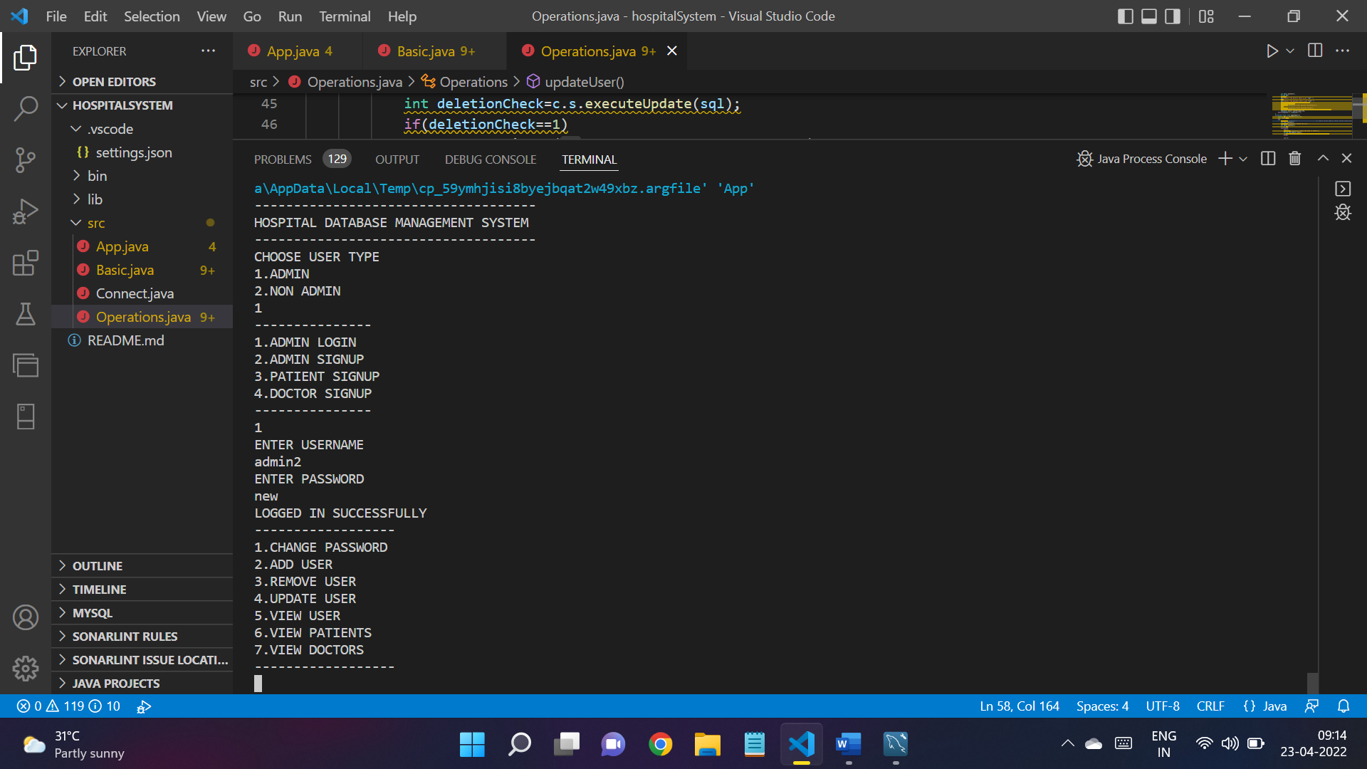

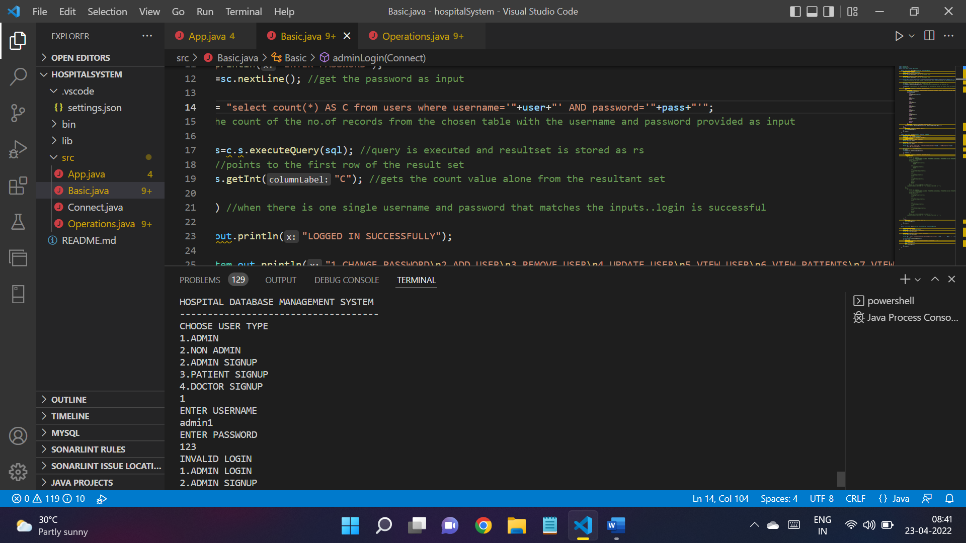

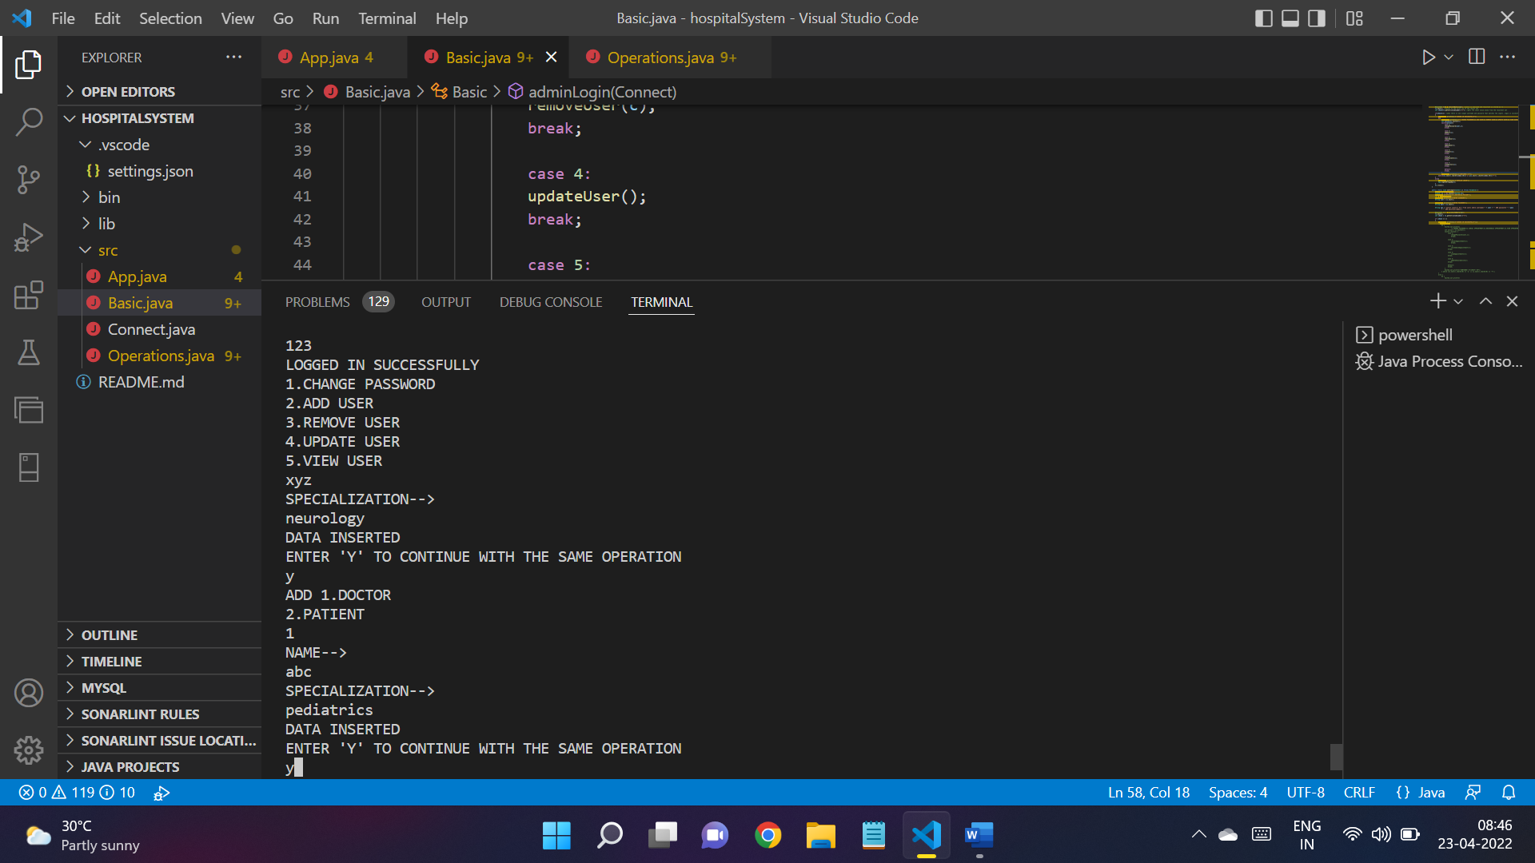

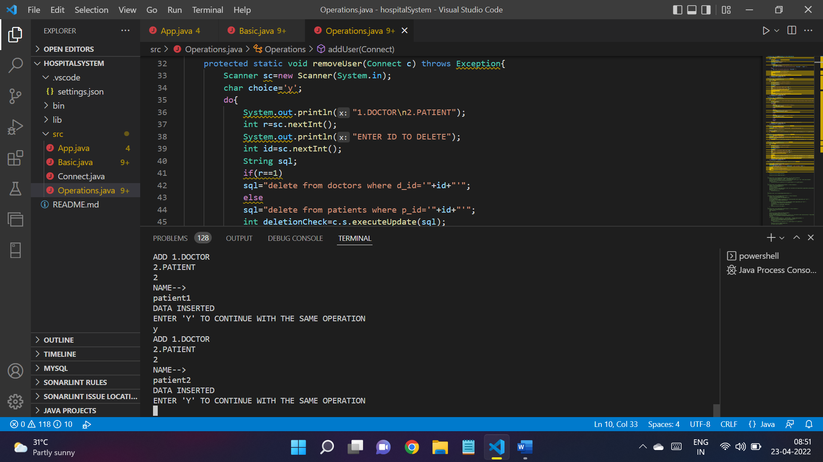

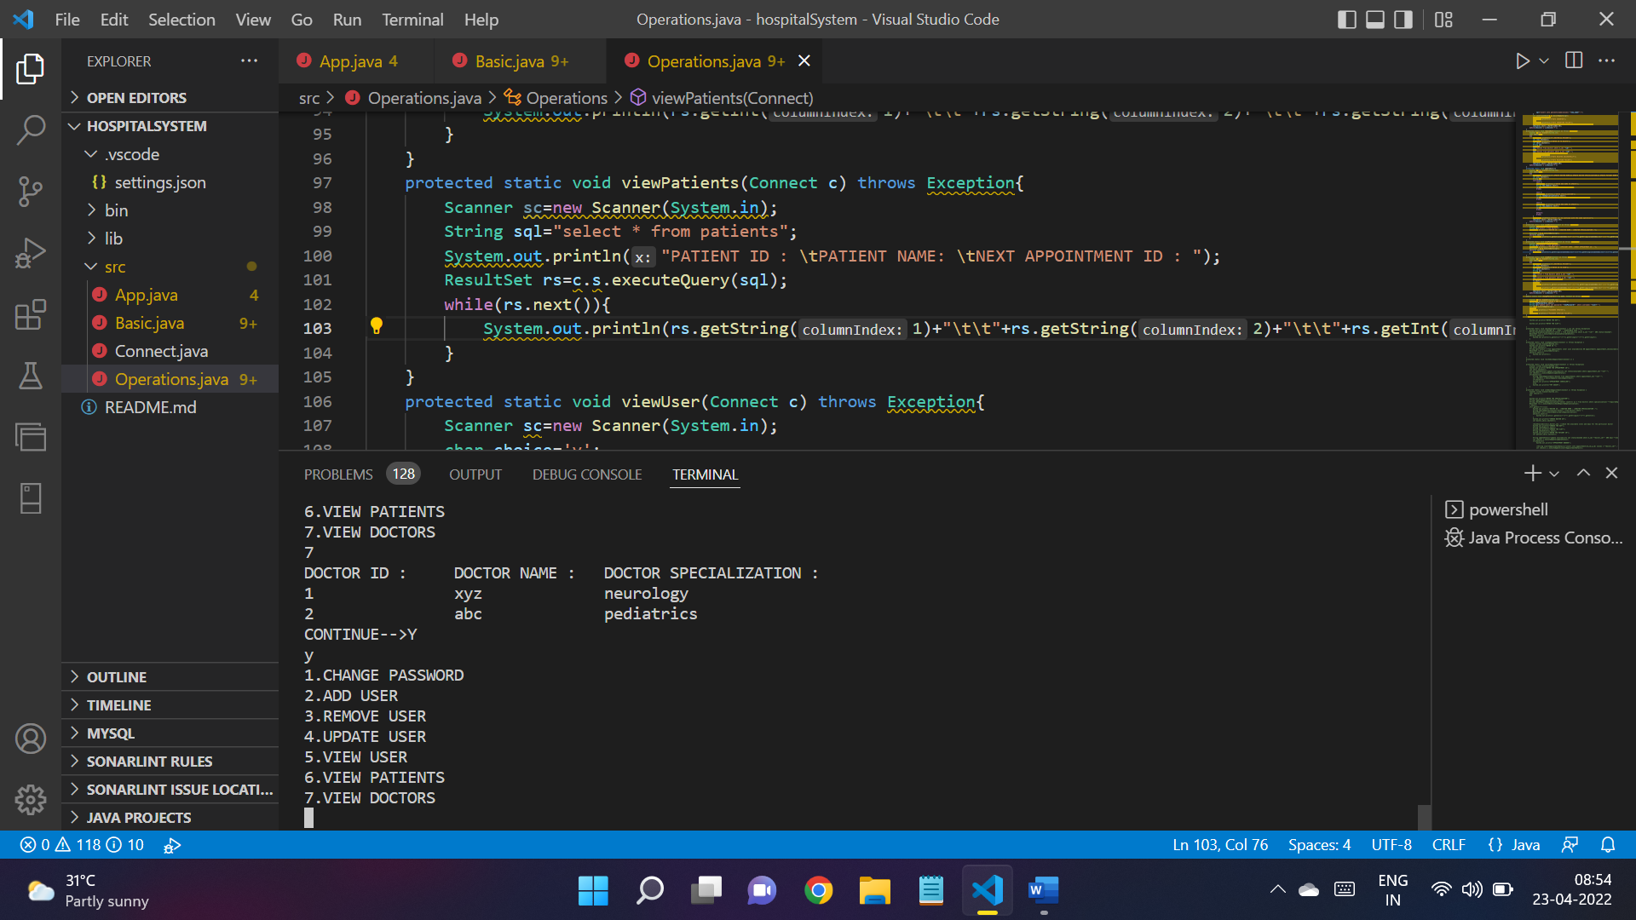

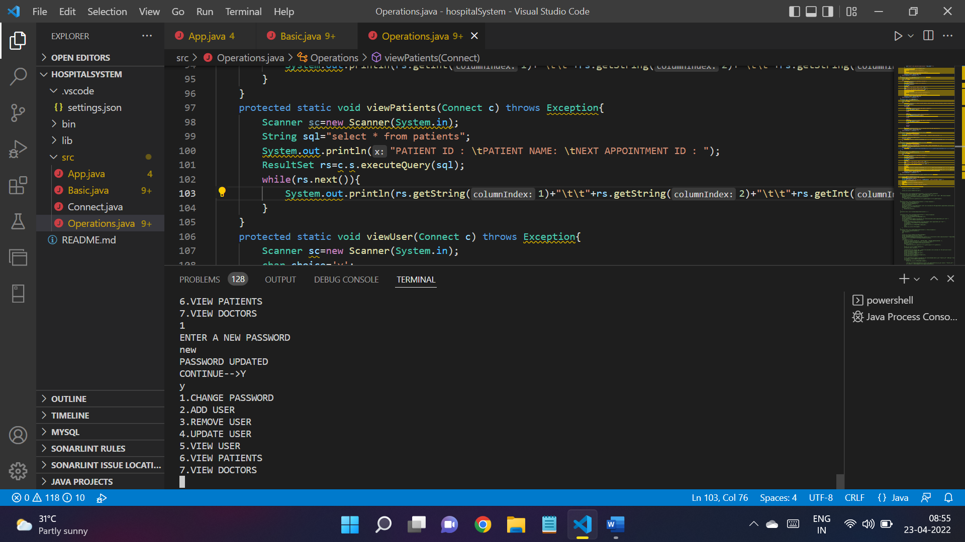

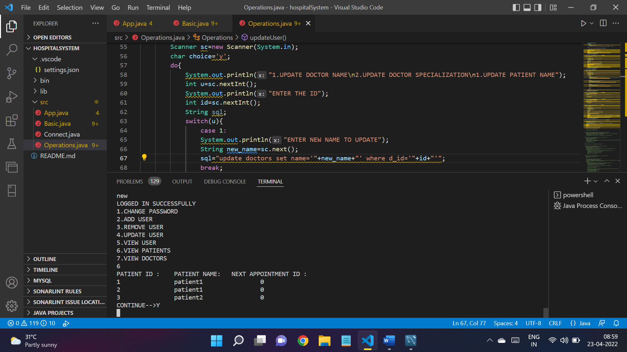

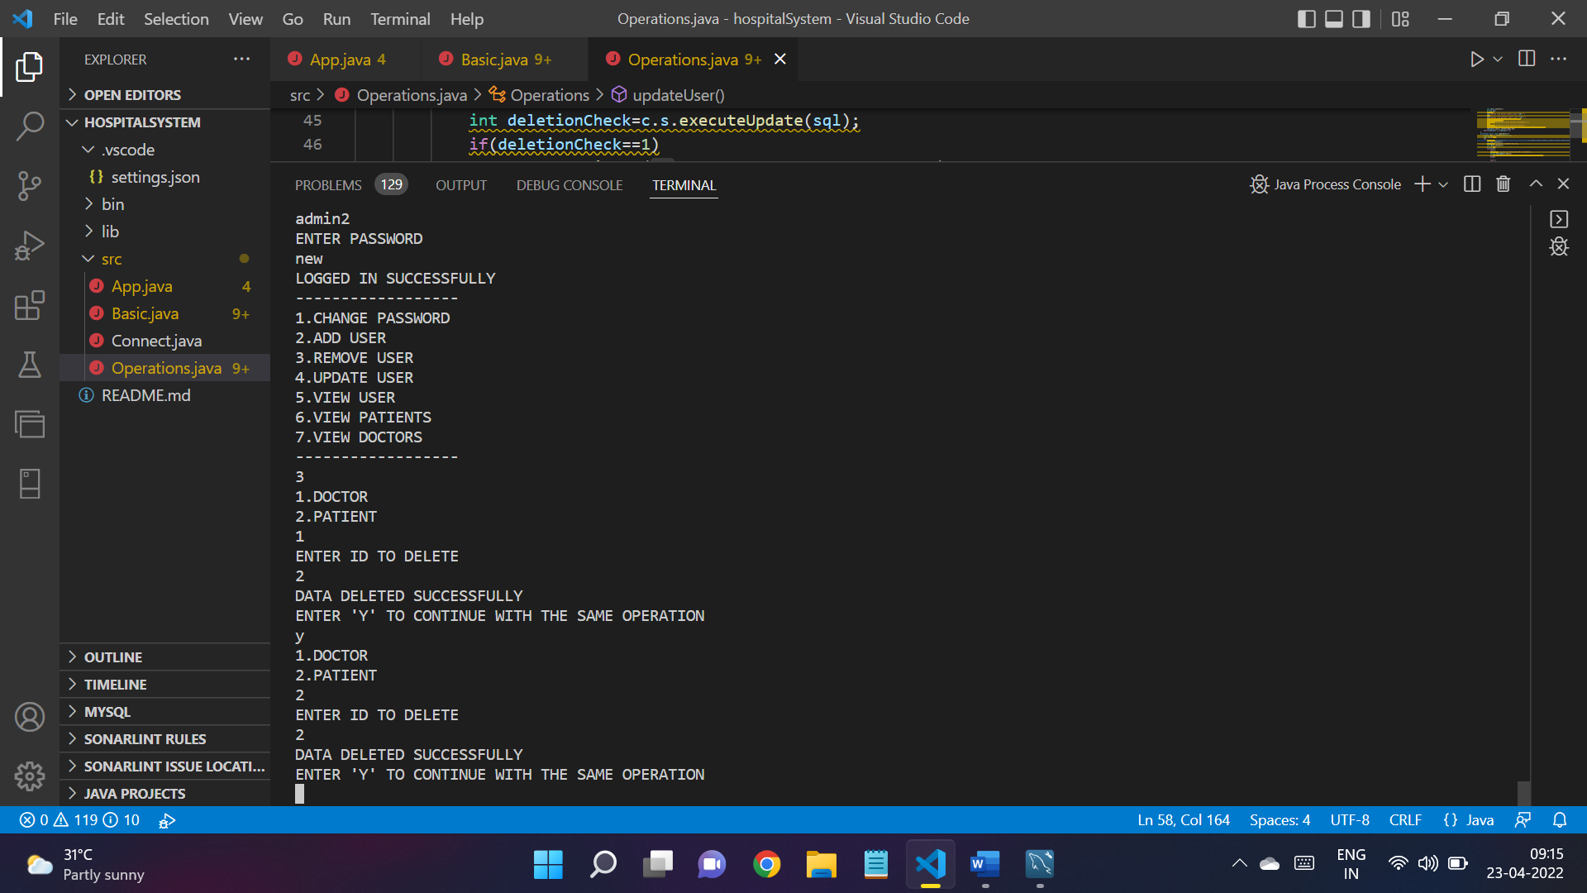

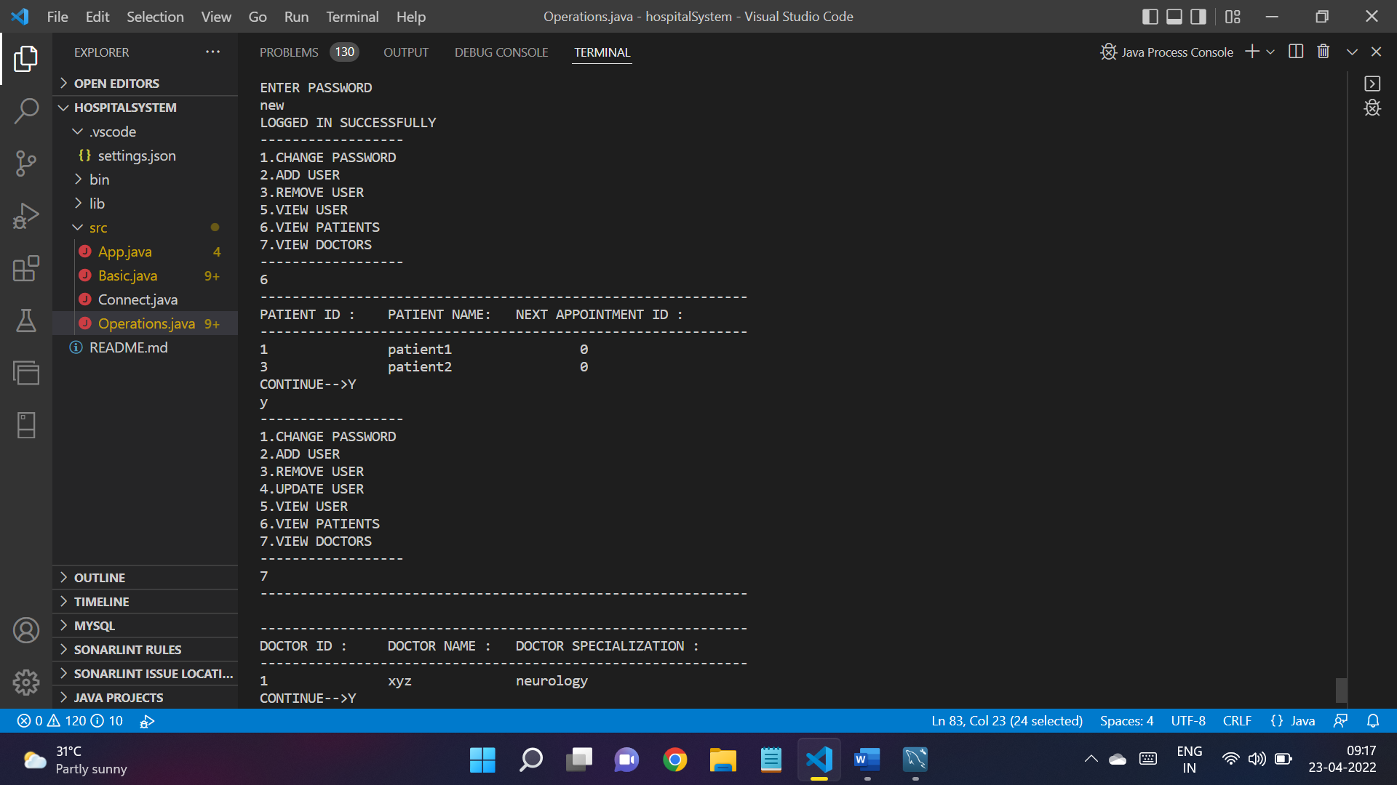

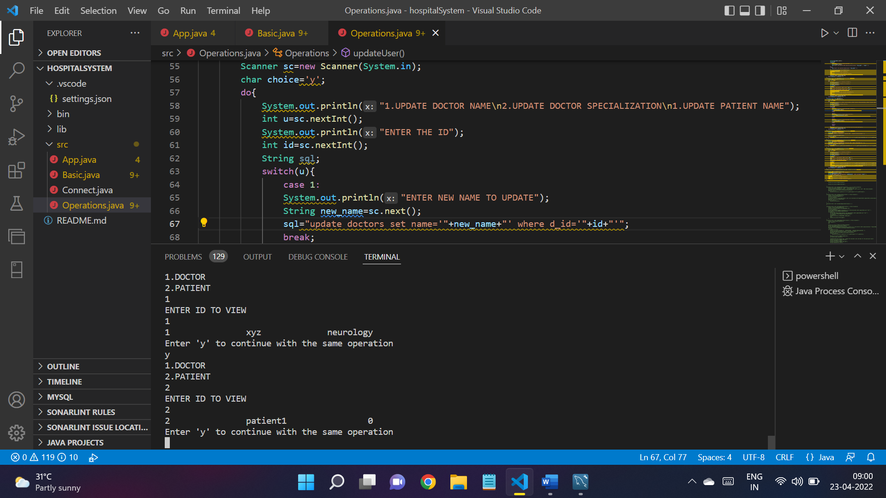

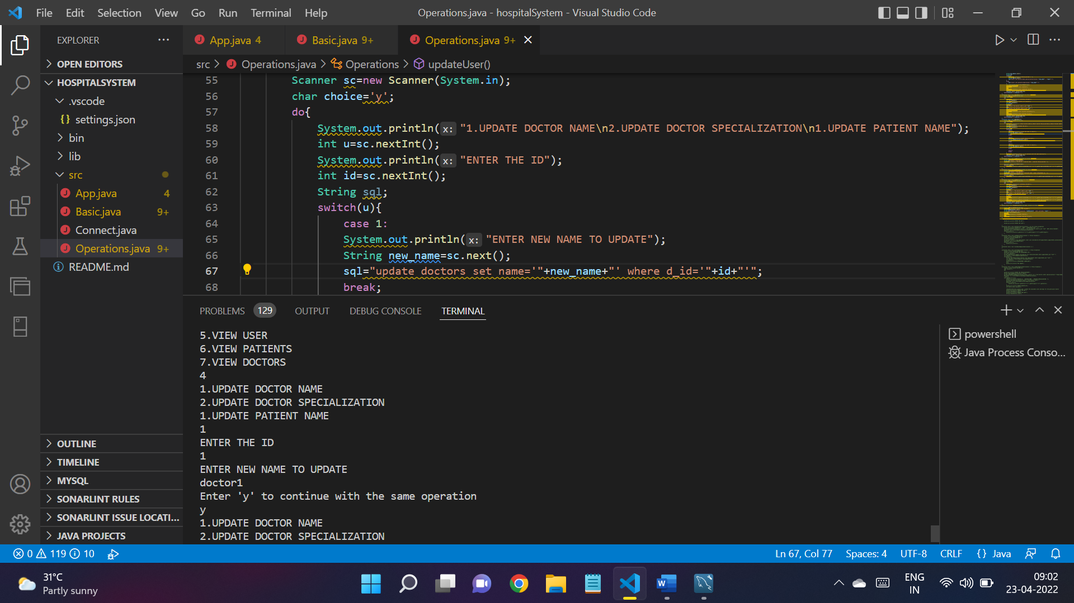

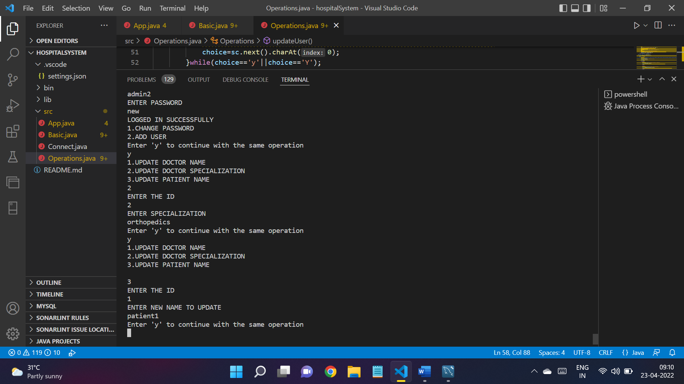

FUNCTIONS:

